#WAP to check if a number is positive or negative

num=int(input("Enter number :"))

if(num>=0):

 print("Positive number")

else:

 print("Negative number")

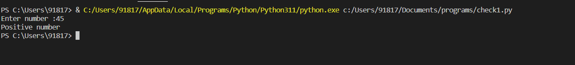

#WAP to check a number is divisible by 5 as well as 3

num=int(input("Enter the number:"))

if((num%5==0)and(num%3==0)):

    print("divisible number")

else:

    print("Not divisible")



#WAP to find a given character is vowel or consonant

ch=input("Enter a character:")

if(ch=='a' or ch=='e' or ch=='i' or ch=='o' or ch=='u' or ch=='A' or ch=='E' or ch=='I' or ch=='O' or ch=='U'):

    print("Vowel")

else:

    print("Consonant")

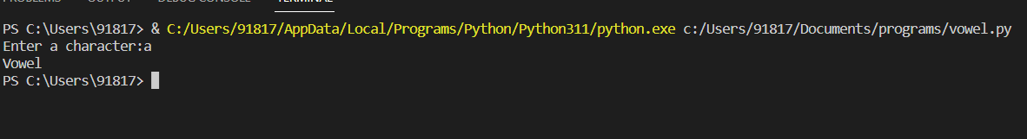

#WAP to make calculator

ch=input("Enter an operator:")

n1=int(input("Enter 1st number :"))

n2=int(input("Enter 2nd number :"))

if(ch=='+'):

       print(n1+n2)

elif(ch=='-'):

    print(n1-n2)

elif(ch=='\*'):

    print(n1\*n2)

elif(ch=='/'):

    print(n1/n2)

else:

    print("Invalid operator”)

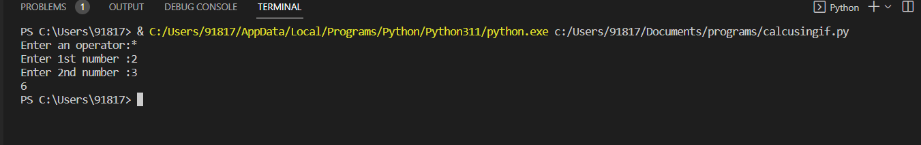

n1=int(input("Enter 1st number:"))

n2=int(input("Enter 2nd number:"))

n3=int(input("Enter 3rd number:"))

if(n1>n2 and n1>n3):

    print("n1 is largest")

elif(n2>n3 and n2>n1):

    print("n2 is largest")

else:

    print("n3 is largest")

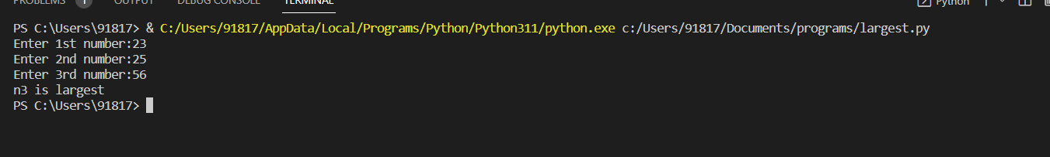

#WAP to calculate grades of student

marks=int(input("Enter the number:"))

if(marks>=90 and marks<100):

    print("A+")

elif(marks>=80 and marks<90):

    print("A")

elif(marks>=70 and marks<80):

    print("B+")

elif(marks>=60 and marks<70):

    print("B")

elif(marks>=50 and marks<60):

    print("C")

elif(marks>=40 and marks<50):

    print("D")

elif(marks>=30 and marks<40):

    print("E")

else:

    print("F")

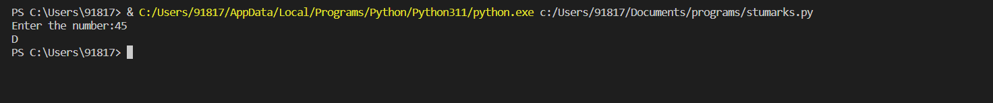

#WAP to input a year and check it is leap year or not

yr=int(input("Enter year:"))

if(yr%100==0):

    if(yr%400==0):

        print("Leap year")

elif(yr%4==0):

    print("leap year")

else:

    print("Non leap year")

